**Applying for Jobs**

Job Searching is functionality that allows you to search for other jobs in the organization. This displays all aspects of the job profile, including the job description, requirements, and responsibilities.

**1** The level of priority assigned by Human Resources. High (red), Medium (green), Low (gray)

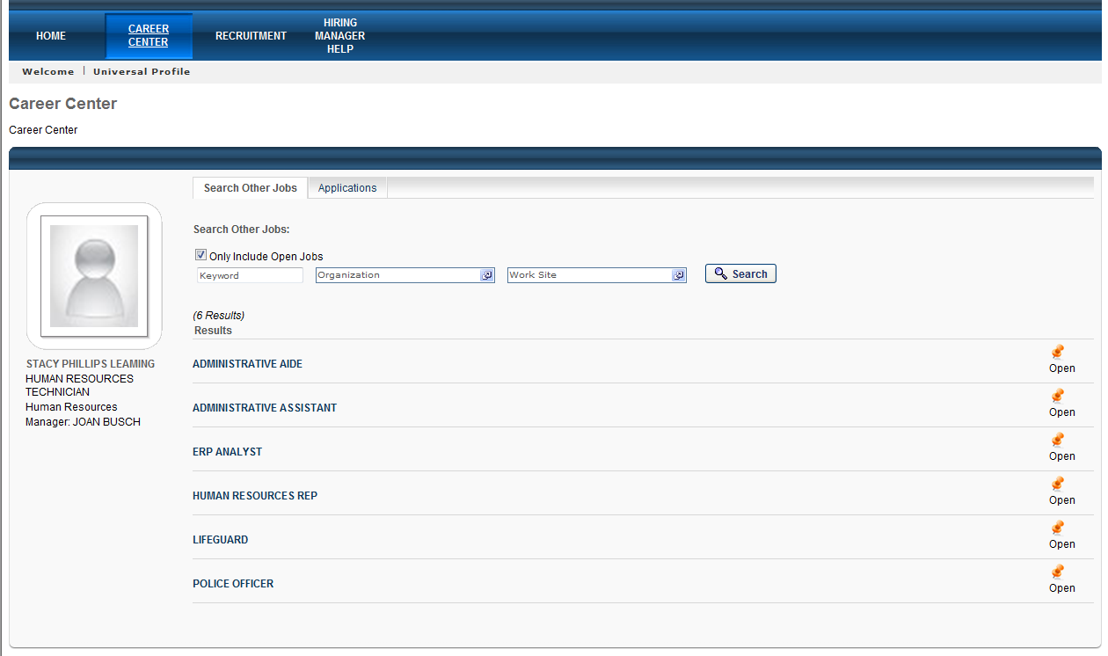

**3** The level of priority assigned by Human Resources. High (red), Medium (green), Low (gray)

**2** The level of priority assigned by Human Resources. High (red), Medium (green), Low (gray)

**4** The level of priority assigned by Human Resources. High (red), Medium (green), Low (gray)

1. **Career Center** – Click on the **Career Center** menu tab to launch the Career Center. This is the area where employees with a Cornerstone login will apply for job postings.
2. **Open Jobs** – Select this checkbox to only include open jobs in the search
   1. Keyword - Enter keywords to search for open jobs that match the keyword. This searches job requisition titles and descriptions. *Optional field*
   2. Organization - Click the Organization field to select a specific Organization for the search. *Optional field*
   3. Work Site - Click the Work Site field to select a specific job location for the search. This limits the search to the selected location. *Optional field*
3. **Search box** – click this box to display search results
4. **Job title results** – available open jobs display in the list. Click on a title to view the job announcement details and apply.

**Adding an Email**

If you are using the system to apply for a job, you will want to make sure you have an email address setup so you can receive notifications about your application. Use this process to add an email address to your Cornerstone account if you do not have a City email account.

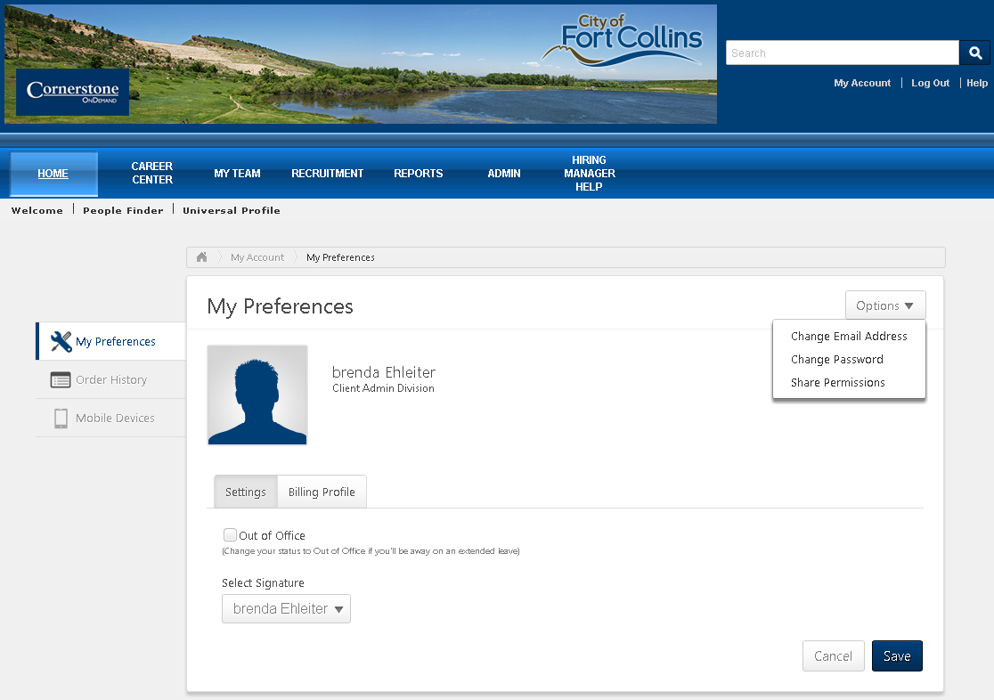

**1** The level of priority assigned by Human Resources. High (red), Medium (green), Low (gray)

**2** The level of priority assigned by Human Resources. High (red), Medium (green), Low (gray)

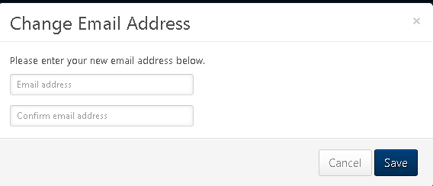

**4** The level of priority assigned by Human Resources. High (red), Medium (green), Low (gray)

**3** The level of priority assigned by Human Resources. High (red), Medium (green), Low (gray)

1. **My Account** – Click on the **My Account** in top right corner of main page.
2. **Options** – Click on down arrow to open Options window and select **Change Email Address**.
3. **Email Address field** – enter new email address.
4. **Save**– click Save button to save your changes. **Please note**: Email will only be saved if you do not have a current City email address.